RUIDA Software installation instructions:

Step 1: Plug in the provided memory stick into your USB port on your laptop/computer.

Step 2: Open or double click the file labelled RDWorksV8Setup and allow the app to make changes to your device.

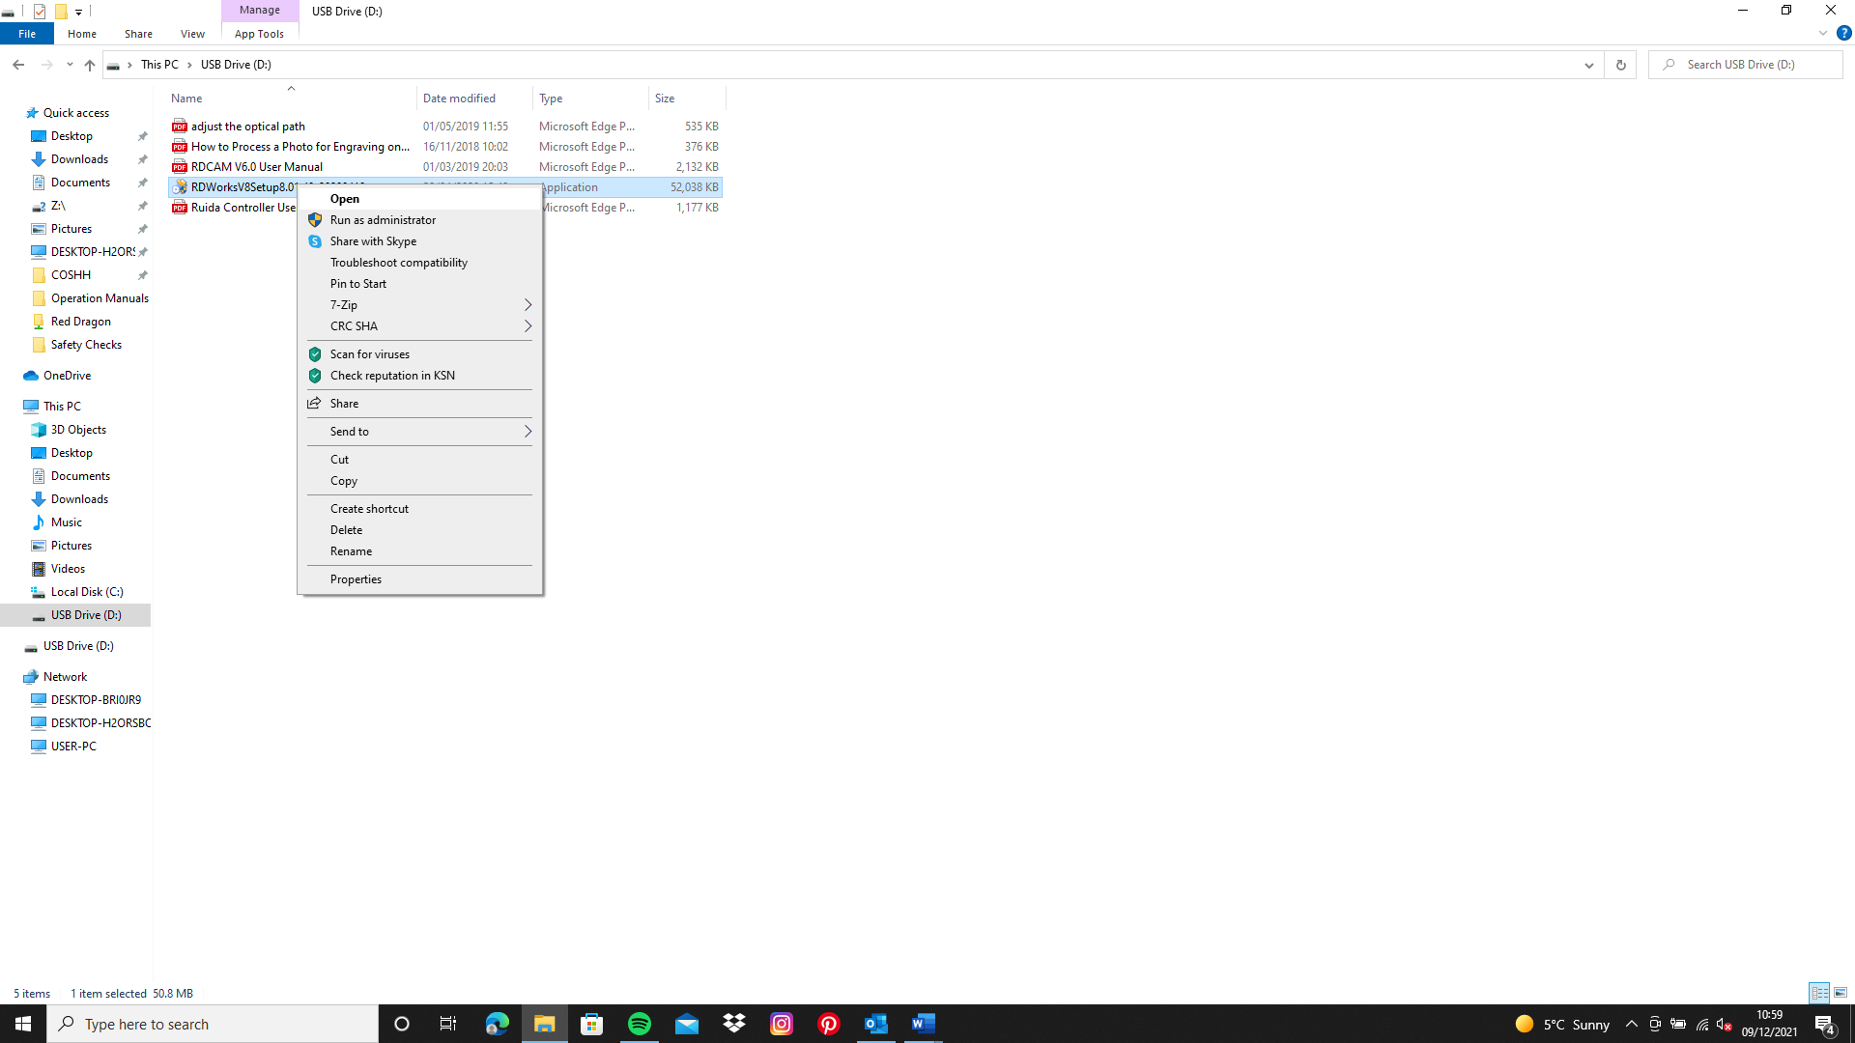

Step 3: Press Install.

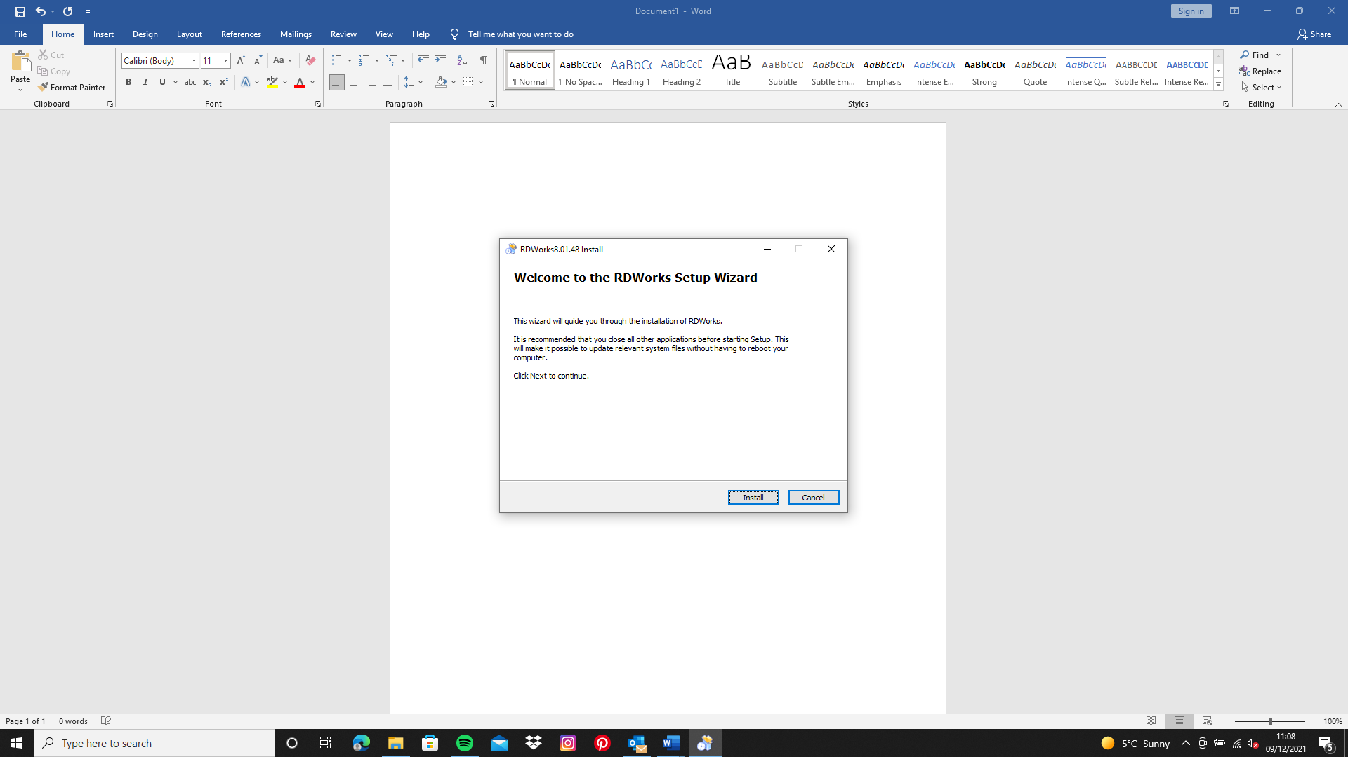

Step 4: Connect your PC/Laptop to the laser machine with the USB cable provided and make sure the laser machine is on.

Step 5: Set the origin to top left or top right depending on where your laser head goes on start up or reset.

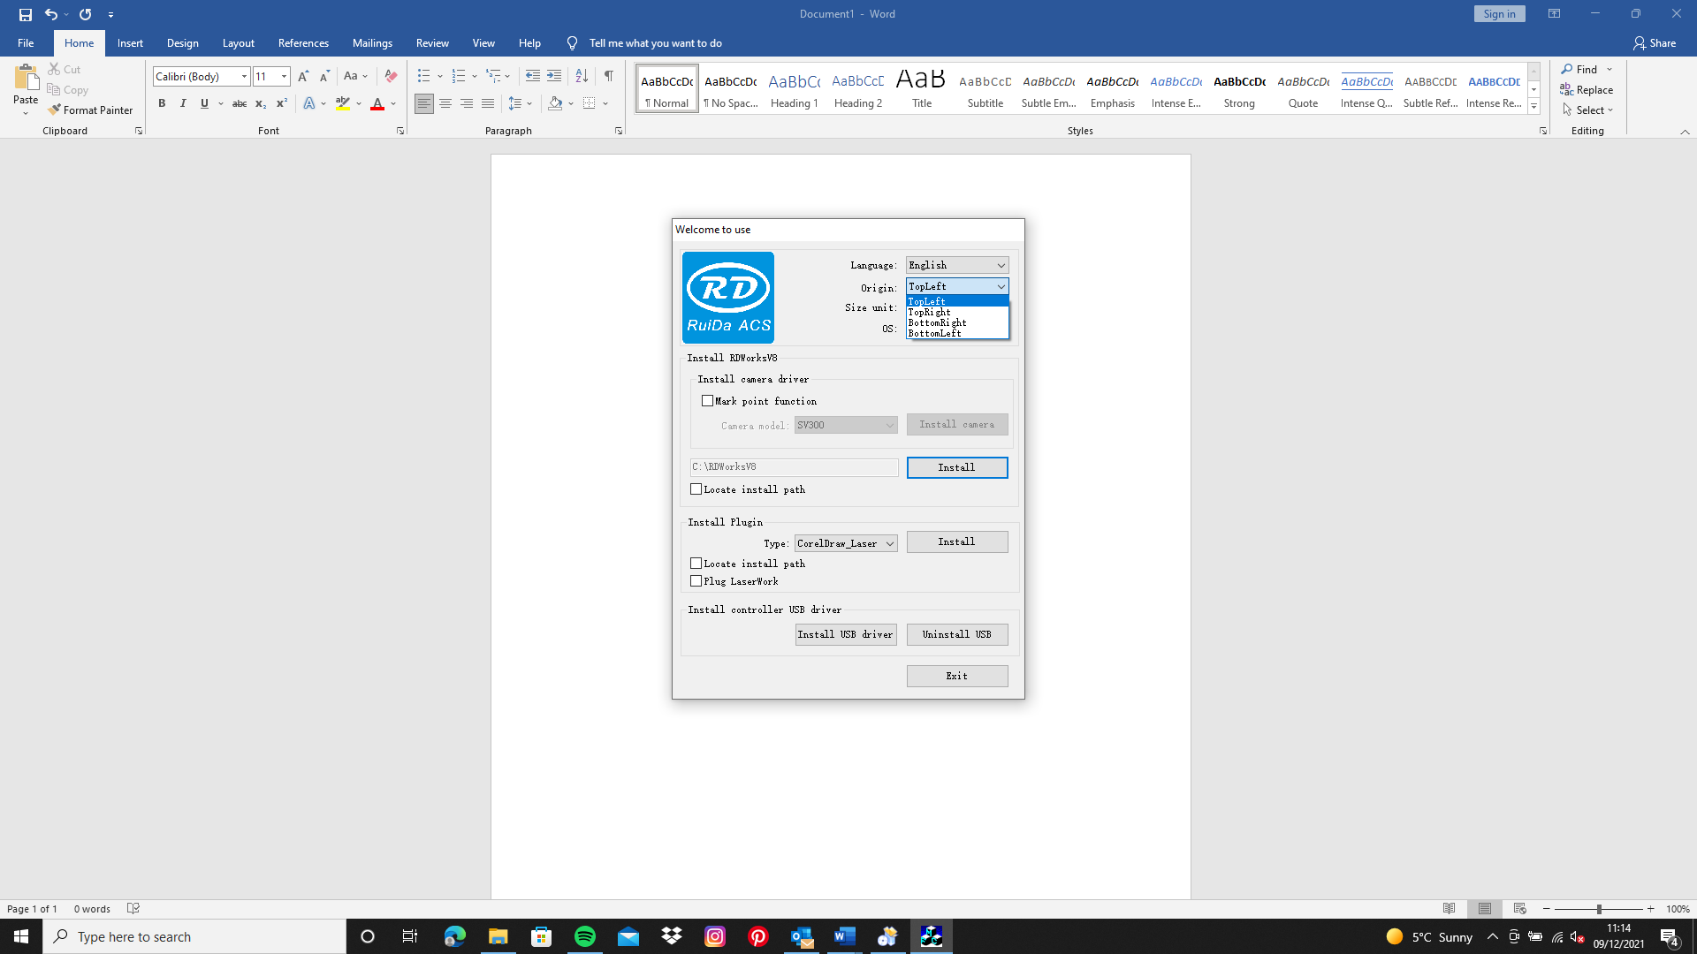

Step 6: Press Install USB driver first.

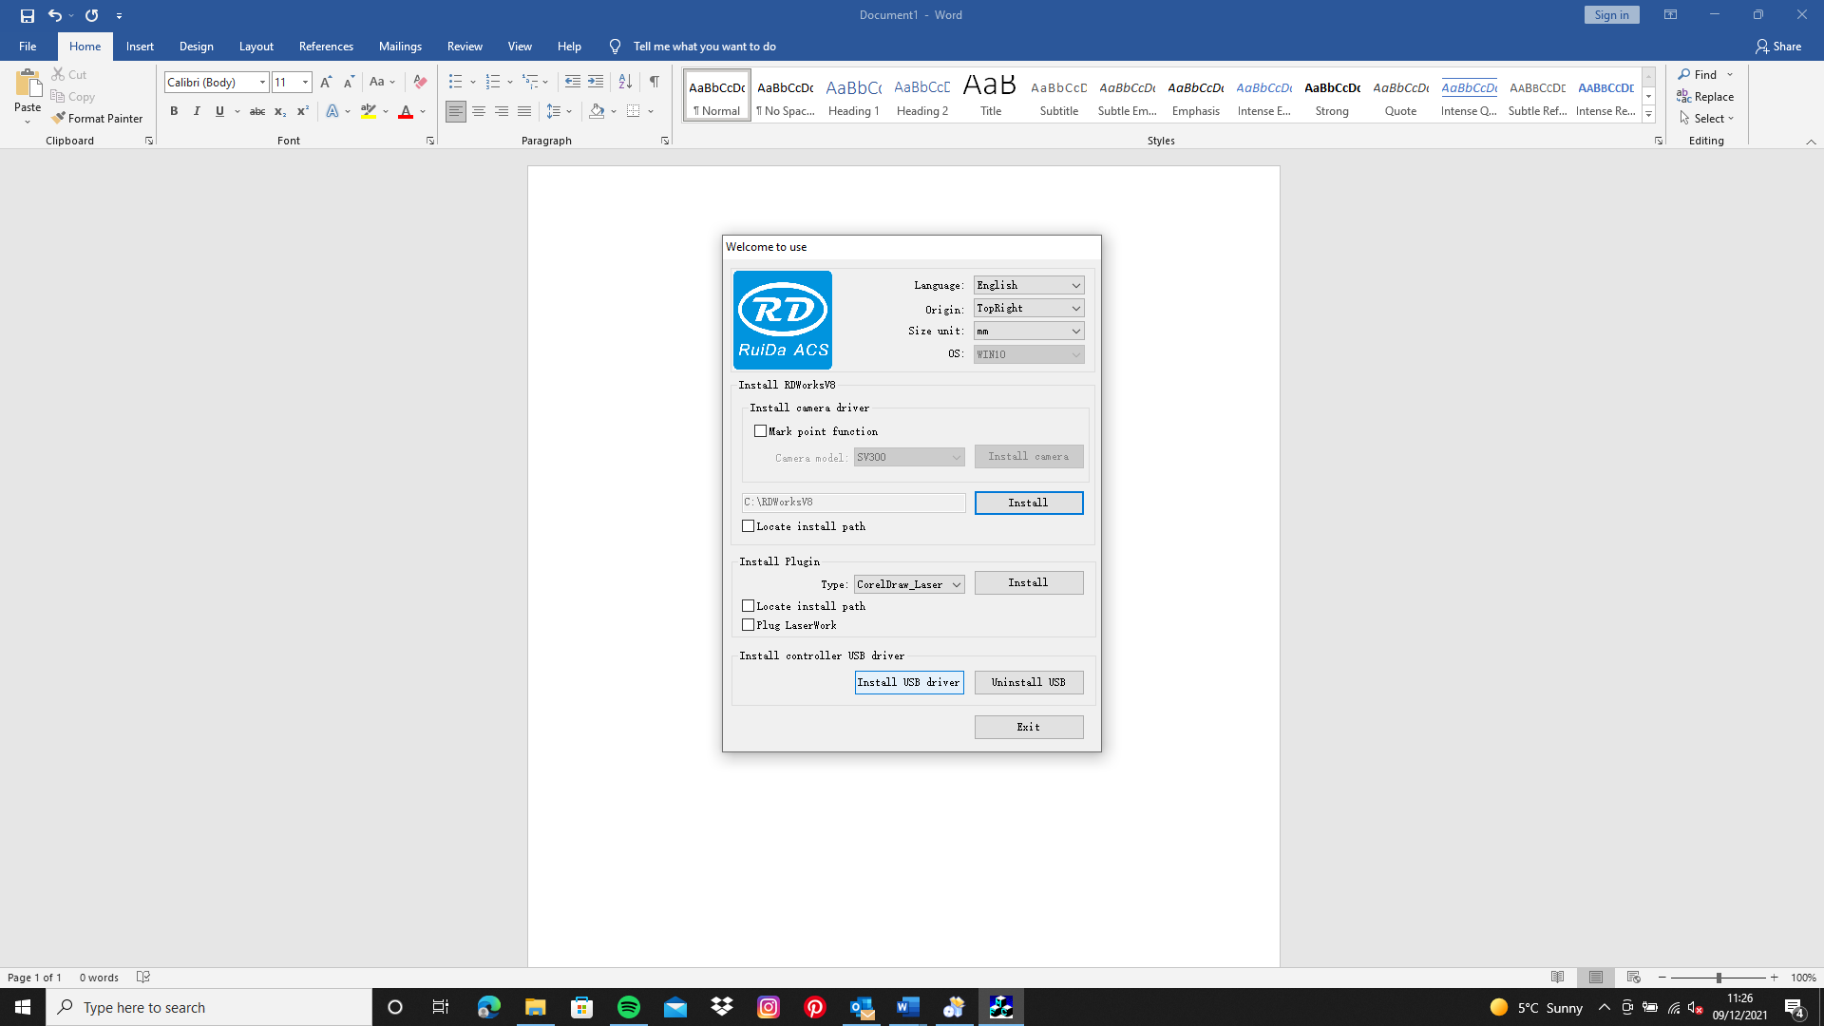

Step 7: Press Install, if you want to put your software in a specific folder press Locate Install Path first then press Install.

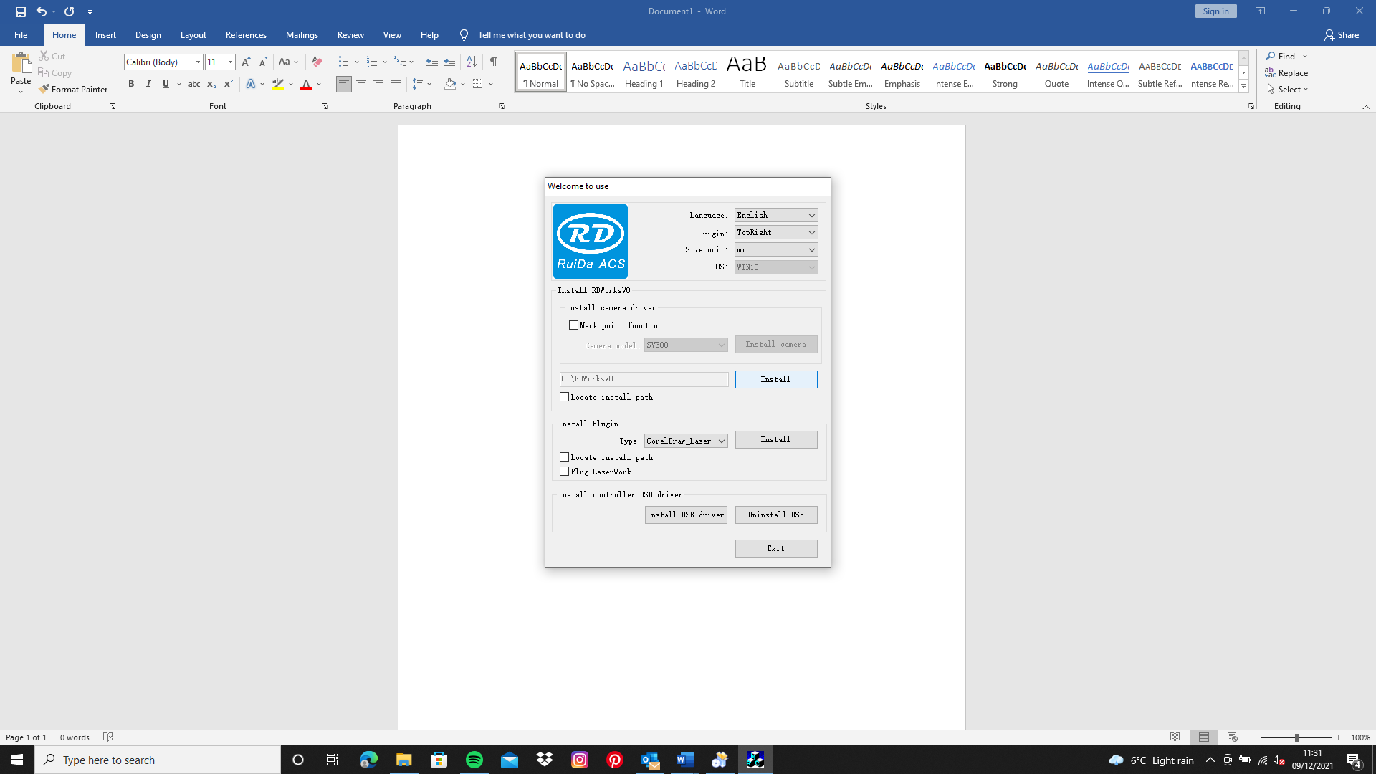

Step 8: (optional) If you will be using other software such as CorelDraw you will need to select the plugin from the drop-down box and then install. If you are just using RDworks just click exit. Supported software are CorelDraw, AutoCAD, EngraveLab and Illustrator.

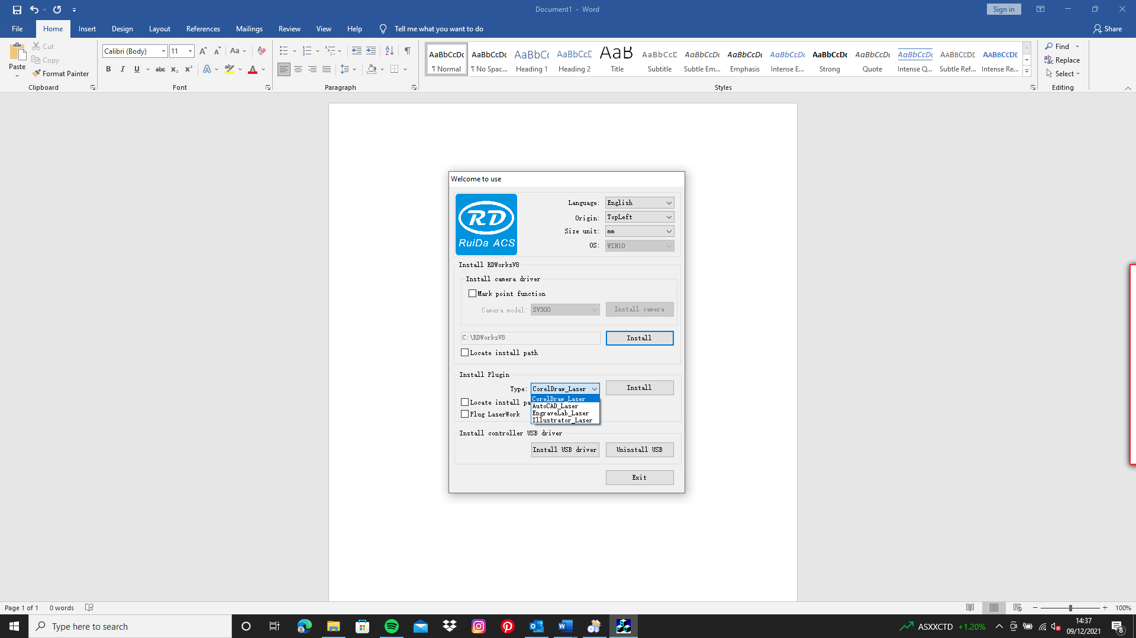

Step 9: Locate RDWorks on your desktop and double click to open

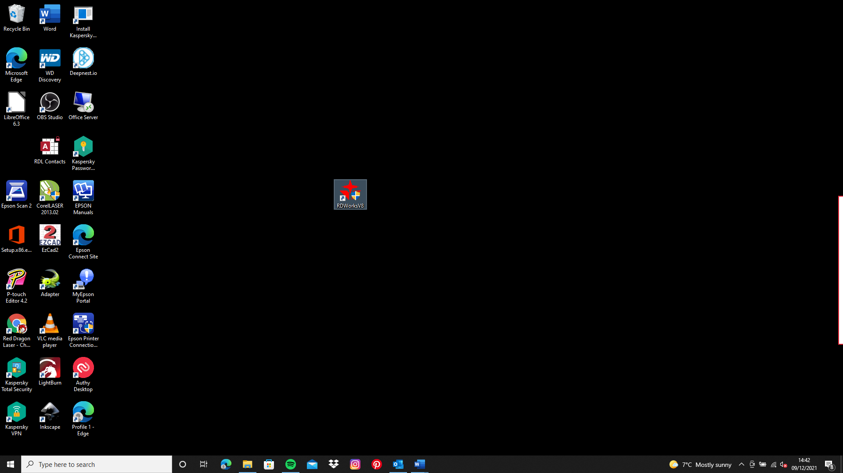

Step 10: Go to file and select Vendor Settings then enter the password “rd8888”

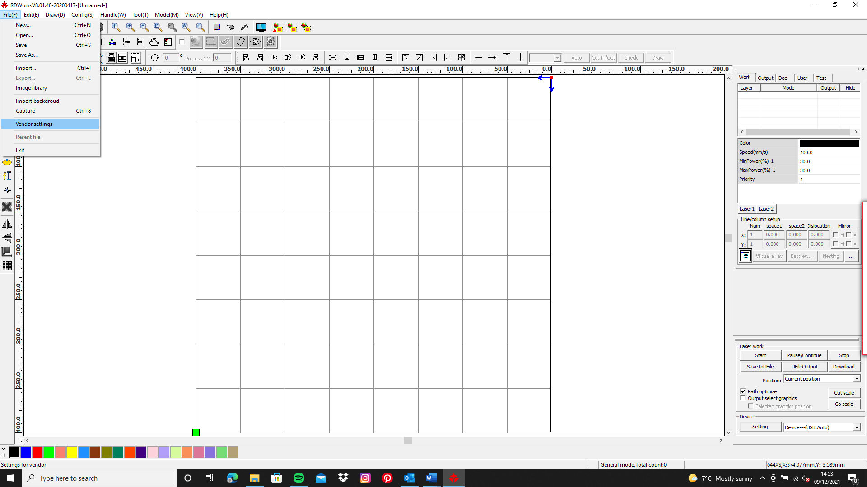

Step 11: On the Vendor tools screen select other which is on the left side underneath laser, when you have done that first click “read” then click “enable protect” then click “write” and you are ready to work. Just exit that screen.

