
Mirror Alignment

Introduction

Firstly, familiarise yourself with the locations of each individual mirror. There are a total of 3 mirrors.

MIRROR 1 is located at the back of the machine, in the top left. In some cases, this mirror can be difficult to reach. If unable to reach from the front, you can remove the back panel of the machine.

MIRROR 2 is located to the left of the machine, attached to the far left of the gantry.

MIRROR 3 is located above the laser head/nozzle, on the inside.

1

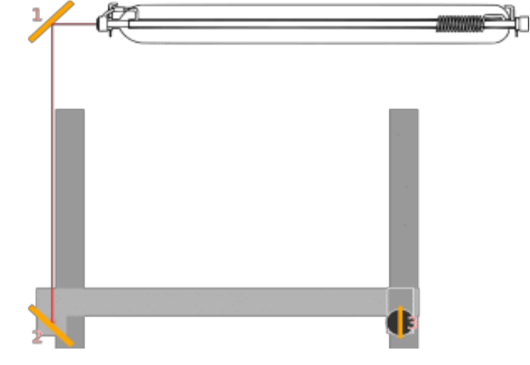

2
3

Check Alignment with Pulse Test

Step One – Tube to MIRROR 1

When it comes to checking the alignment, the best way is to use the ‘Pulse’ button on the controller panel. Although it is very unlikely that the laser beam from the tube to MIRROR 1 will be out of alignment.

To check this, place a piece of double-sided tape over MIRROR 1 and press ‘Pulse’. (To do this without getting ‘error message’, you will need to remove the back panel and place a small piece of metal on the proximity sensor)

After a quick pulse, look at the double-sided tape to see where the laser beam has hit. You want to ensure the laser beam is hitting as close to the centre of the mirror.

Step Two – MIRROR 1 to MIRROR 2

Using the controller panel directional arrows (UP and DOWN),
move the centre gantry as close to the back of the bed as possible. This creates the smallest distance between MIRROR 1 and MIRROR 2.

Place some double-sided tape over MIRROR 2 and pulse. You want to ensure that the laser beam is hitting as close to the centre of the mirror as possible.

Repeat this process for MIRROR 2 with the centre gantry as close to the front as possible. This will create the furthest distance between MIRROR 1 and MIRROR 2 and can ensure that the laser beam is best aligned.

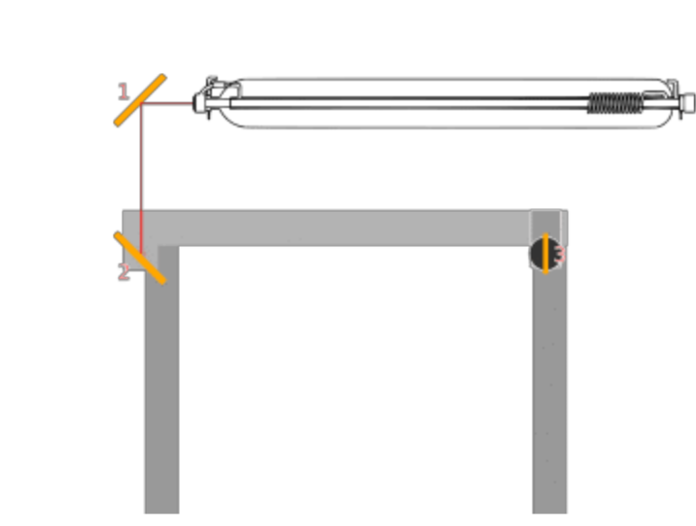
*(IF THERE IS NO ALIGNMENT ISSUE AT THIS STAGE, CONTINUE READING. IF ALIGNMENT IS OUT, SKIP TO PAGE 4)*

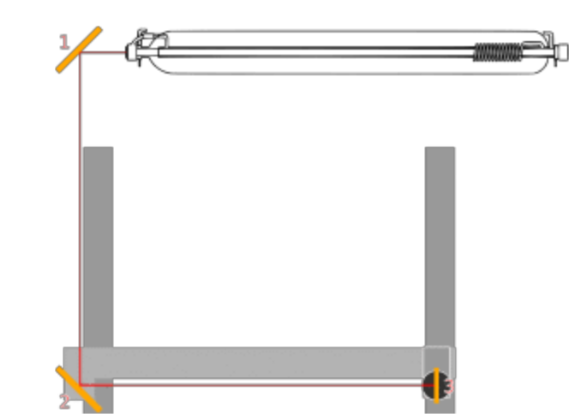

Step Three – MIRROR 2 to MIRROR 3

To check the alignment between MIRROR 2 and MIRROR 3, there will be a minimum of 4 pulse tests. (One in each corner)

Firstly, using the controller panel directional arrows, move the head of the laser to the back far left corner of the machine. Once in place, cover the hole for MIRROR 3 with double-sided tape. Pulse the laser to see the mark on the tape.

Keeping the gantry at the back of the machine, move only the laser head to the far right corner of the machine. Using the same piece of tape or another, cover the hole and pulse.

*(IF ALIGNMENT IS OUT AT THIS STAGE, SKIP TO PAGE 4) *

Repeat this process by bringing the gantry to the front of the bed and the laser head to the far left. Place double-sided tape over the mirror and pulse.

Repeat the process by keeping the gantry at the front of the machine and move the laser head to the far right of the machine. Using the same piece of tape or another, cover the hole and pulse.

When pulsing in each corner, ensure that the laser beam is hitting as close to the centre of the mirror as possible – it doesn’t need to be dead centre on each corner! As long as the laser beam is within the area of the mirror it will be fine.

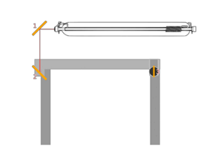

2
1

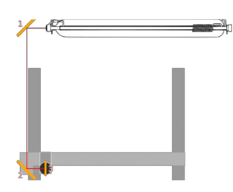
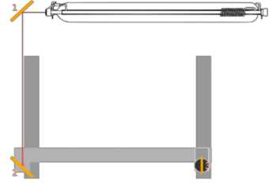

3
4

Step Four – MIRROR 3 to Nozzle

The last stage in checking mirror alignment will be MIRROR 3 down to the end of the nozzle.

After checking all four corners are aligned from MIRROR 2 to MIRROR 3, bring the laser head to the centre of the bed space.

Place some double-sided tape at the end of the laser nozzle where the beam comes out and pulse.

The laser beam should make a perfect circle if it is aligned. If the laser beam is not aligned, it will hit the side of the nozzle, creating an imperfect circle.

You will need to adjust the mirrors accordingly, to get a perfect circle.

Adjusting the Mirrors

There are three adjustment screws on the mirrors. Different screws move the mirrors in different directions.
First, you must loosen the locking nut. You will want to be extra careful when loosening or tightening the lock nut.

Adjust each screw a fraction of a turn, in accordance with the mark on the double-sided tape. After each adjustment, pulse the laser beam to see where the beam hits the tape.
Once happy with the alignment, do not forget to tighten the locking nut on each screw when you have finished each step.

Adjust each screw slowly, carefully and ONE AT A TIME ONLY.
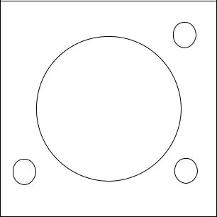

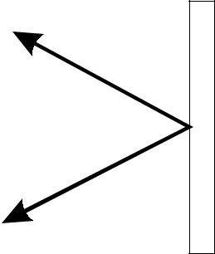
3
Screw 3 - Adjustment
Up and Down

1 2
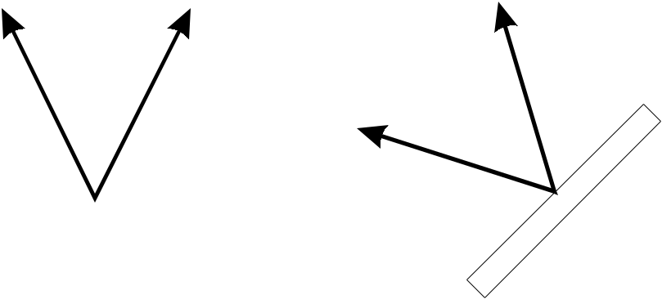

 |  | Screw 2 – Adjustment
Screw 1 – Adjustment |  | Corner to Corner
Left to Right

