Camera Calibration

Calibrating the camera is quite simple and will not take much of your time.

Firstly, make sure the camera is attached to the lid of your machine, pointing towards the bed space. Once you have the camera in place, connect the camera to your device (PC/Laptop).

Turn on the laser machine, as well as your laptop and open RDWorksV8 software.

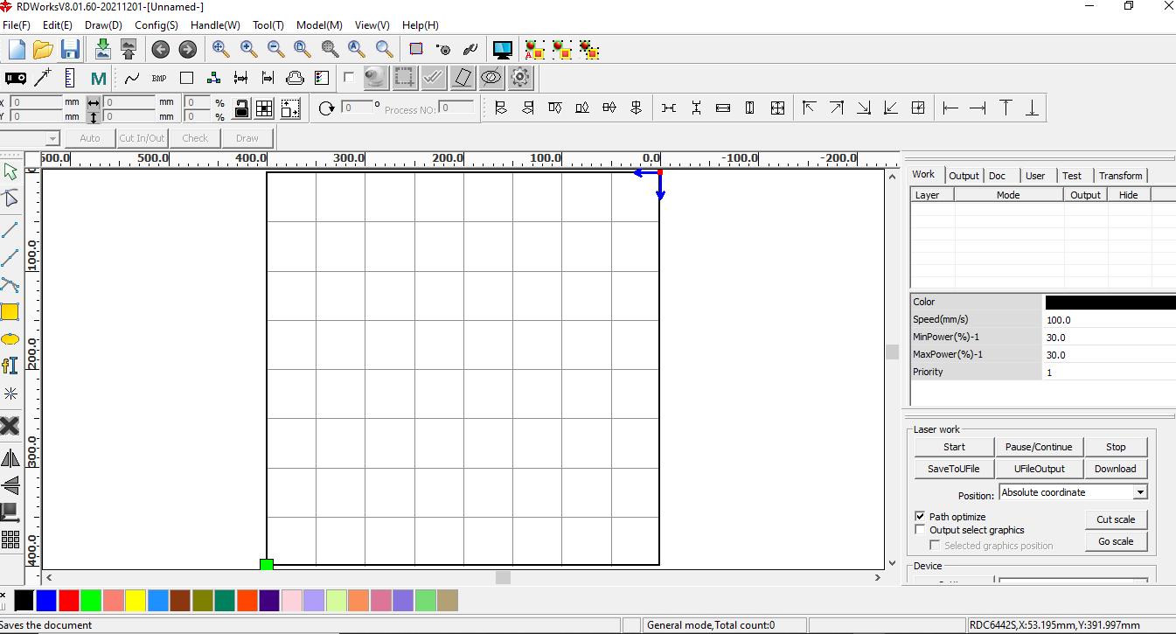Once RDWorks is open, you will then have to select the camera function, by ticking the small box, left of the camera icon (as shown below).

Once selected a prompt will appear reading **“Enable Canvas Function”**

Press **‘OK’**. This will enable the camera and should take a picture of the bed space.

*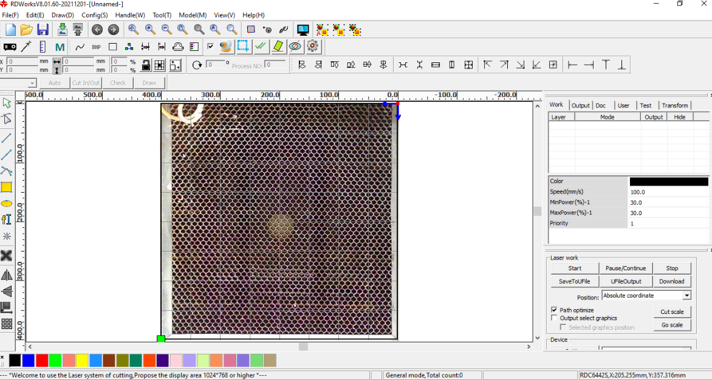(Example)*

Next, you will need to get a piece of material. We suggest using cardboard or ply wood, measuring slightly bigger than the working space itself, roughly 420mm X 420mm – this will allow the grid to be cut within the correct space and not touch the edges of the material.

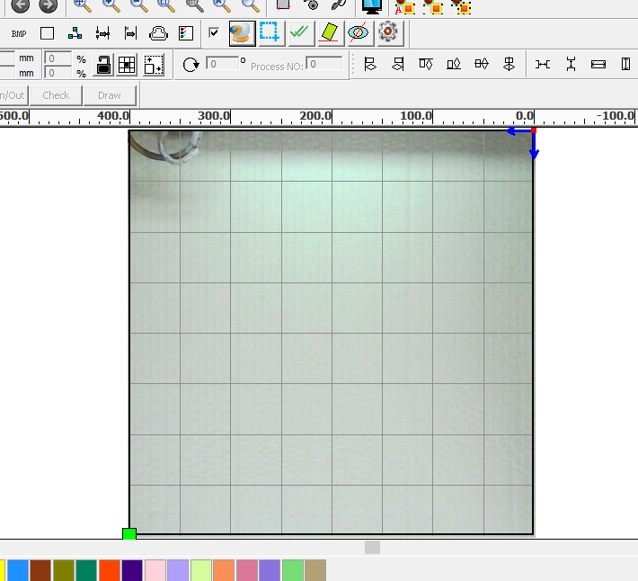Set your material in the machine, making sure your laser head is in either top corner as far as it can go, and press the camera icon in RDWorks to retake the picture. (Shown below)

After you have retaken the picture with the material, the next step is to click on the cog icon to the far right of the camera icon (as shown below).

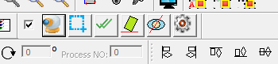

This will then open a new window with settings to calibrate the camera (as shown below).

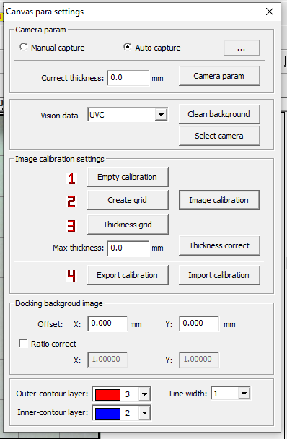

Once the ‘Canvas para settings’ window is open you will need to click on

1. **Empty Calibration**

After it has been emptied, press

1. **Create Grid**

When you press this button, a prompt will appear requiring you to put the required rows/columns for the grid. The software will recommend a setting of 10 rows and 10 columns - we recommend changing it to 13 rows and 13 columns. (4040 machine)

Once you have selected the rows and columns, a grid will appear on your working space (as shown below)

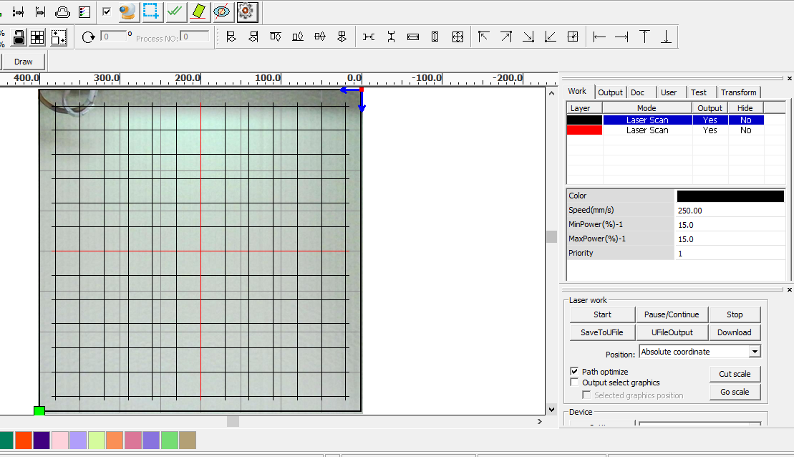You can close the canvas para settings window for now.

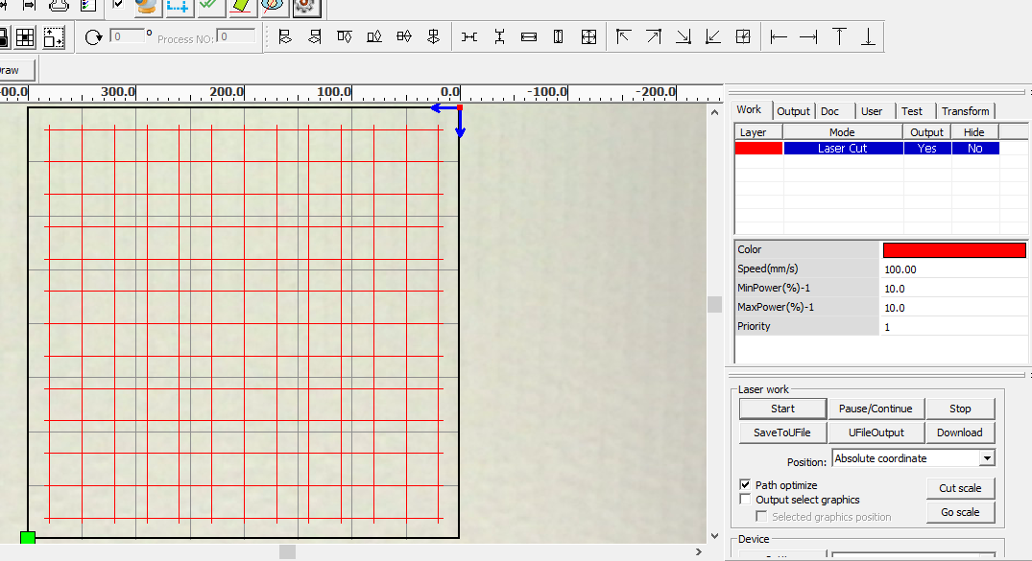Once you have the grid lines on your workspace, it is recommended to change the lines to a set colour to be all the same. You then need to adjust the power and speed to a suitable setting. You do not need to cut through the material, just mark it. The material that we used was cardboard, and only required a setting of 100mm/s and 10% power.

After you have set the desired speed and power settings, hit start and let the machine create the lined grid on your material.

Once the grid has been created on the material, do not move the material and go back into RDWorks and open the ‘Camera para settings’ by clicking on the cog icon.

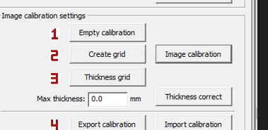

When the window opens, click **‘Image Calibration’.**

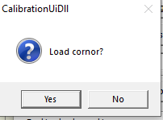

This will then open a prompt asking ‘Load Corner?’ Click **‘Yes’.**

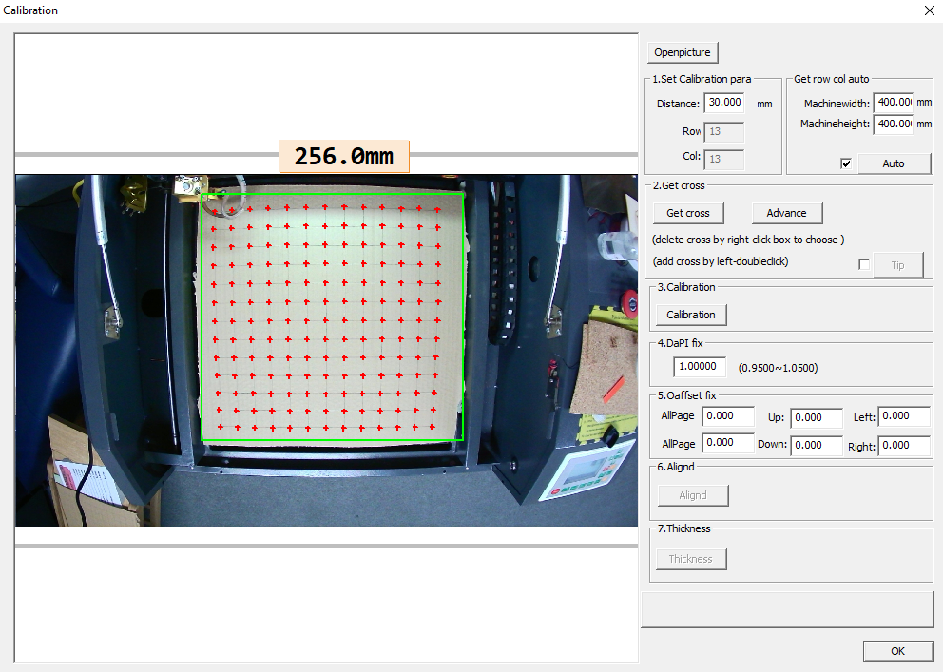After clicking yes, a new window will appear showing the bed space with a green box around the outside and many red crosses.

You want to make sure the green square box is big enough to contain all the columns and rows on the material. You may need to adjust the size of the green box, this can be done by clicking and dragging the edges.

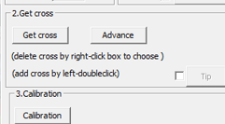

After you have adjusted the green box, click on the **‘Get cross’** button on the right-side panel.

After clicking the ‘Get cross’ button, it will re-mark the red crosses on the grid to match the crosses on your material. Some crosses may be left out (as seen below) and will need to be filled in manually.

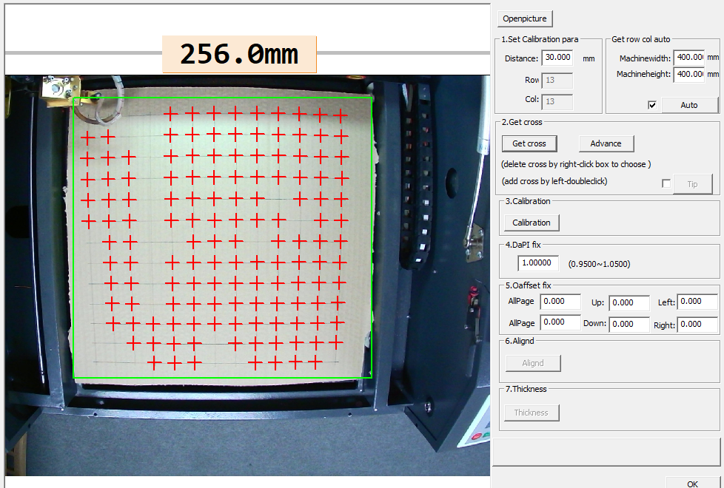

To set the crosses manually, simply double click on where the crosses meet on your material. Fill in the remainder crosses. There should a certain number of crosses that are required for a 13 x 13 grid and the software will prompt you if there are any missing. To delete a cross, right click and drag the mouse over the cross.

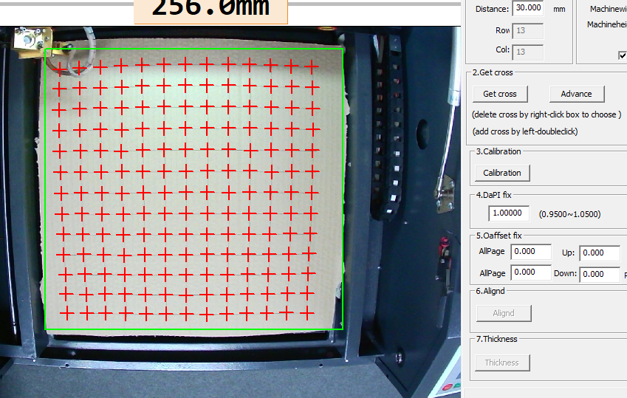

After you have filled in all the crosses, it should look similar to this 🡪

Once you are happy with crosses,

Click the **‘Calibration’** button to the right.

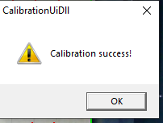If the calibration is a success, you should be prompted with this message.

Now that your camera has been calibrated you can close the ‘Camera para settings’ window.

Remove the material from the bed space and retake a picture with the camera icon at the top.

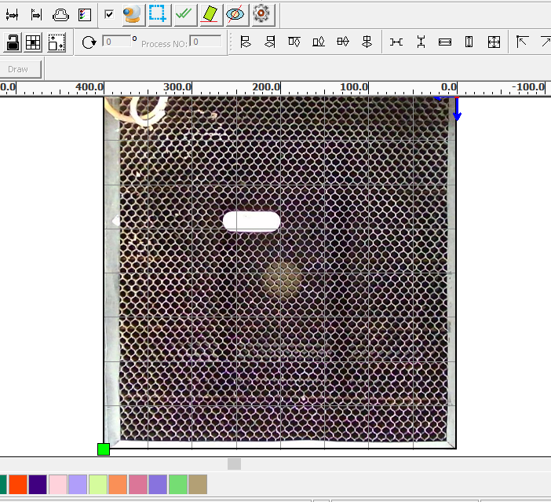As shown in the image below, we have removed the material, placed a wooden USB stick on the bed and retaken the image.

All that you need to do now is create a design and simply place the design over the material where you’d like to engrave/cut.

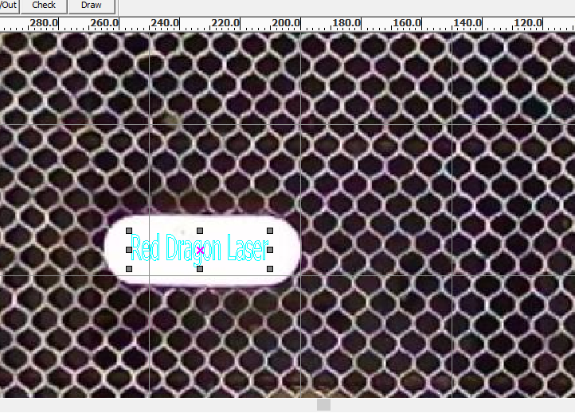

Here we have written some text and placed it over the wooden USB stick.

Once happy with the placement, press Start.