Recalibration

To complete a recalibration test, open RDWorks (this software is provided on a USB).

Once RDWorks is open, create a 100x100mm square.

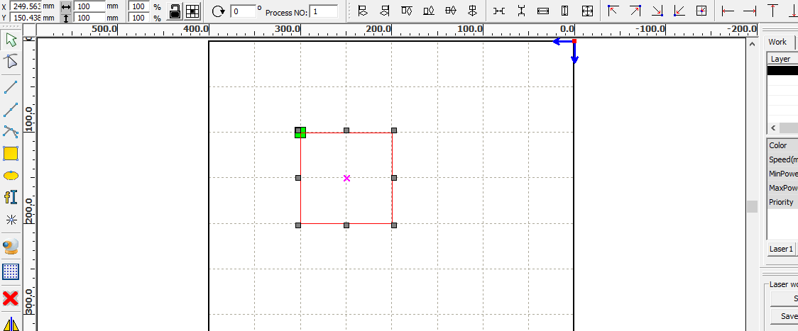

Place some material on the bed, and proceed to cut the square. Adjust setting accordingly - you do not have to cut through the material, as long as the material is marked enough to measure.

If your square is not 100x100m, you will need to do a recalibration.

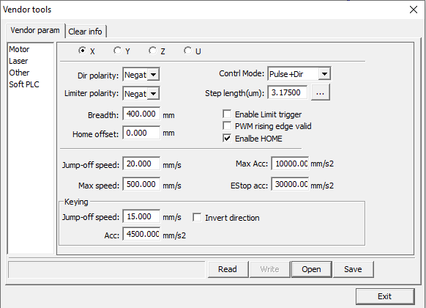In RDWorks, the top left **‘File’ > ‘Vendor Settings’**

Press ‘Read’ to get the software to connect with the machine.

On this page, there are options at the top for the X, Y, Z and U axis.

**X-Axis**

When measuring your square, if the **X axis** is out of measurement, you will need to select the **X** at the top and then click on the button’**…’** right of **‘Step Length(um)’**

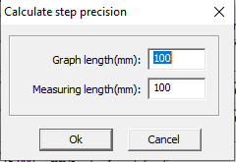

You will be displayed with the above box containing ‘100’ in each box.

If you created a 100x100mm square in RDWorks, leave the box ‘Graph Length(mm)’ with 100.

In the ‘Measuring length(mm)’ box, change this number to what your square cut out measures on the **X-axis**.

**EXAMPLE** - If the square that was cut out measures at 100x93mm, enter as follows –

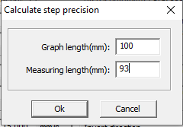

Press ‘OK’ and then leave vendor settings.

If it was just the X-axis that was out of calibration, proceed to cut out another square after changing the settings and measure again. You should now have a 100x100mm square.

**Y-Axis**

Similar to the steps above for the X-axis, you will need to go to **‘File > Vendor Settings’**

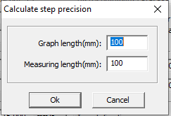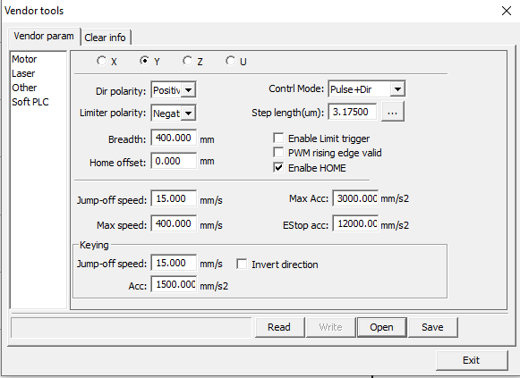This time, you will need to select the **‘Y’** at the top and then the ‘…’ button right of **‘Step length(um)’**

Similar to the steps above, if you created a 100x100mm square in RDWorks, then leave the top box containing 100.

In the ‘Measuring length(mm)’, change this to the amount that was measured on the cut-out square on the **Y-axis**.

**EXAMPLE -** If the square that was cut out measured at 93x100mm, enter as follows:

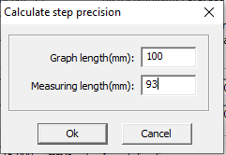

Press ‘OK’ and then leave vendor settings.

Recreate a square in RDWorks at 100x100mm and cut out. You should have a 100x100mm square and your calibration is complete.